# Question 1:

#### Prompt 1: Should I run LLMs on my machine locally?

#### Prompt 2: Hello, My name is Shubham and I need help in drafting an email to my Professor Saty for LOA

#### Prompt 3: Help me understand the reality of Universe

# Question 2:

#### Prompt for frontend code: Write a code to generate a frondend form, which takes details of a employee about their holiday plans. Use Streamlit to do this

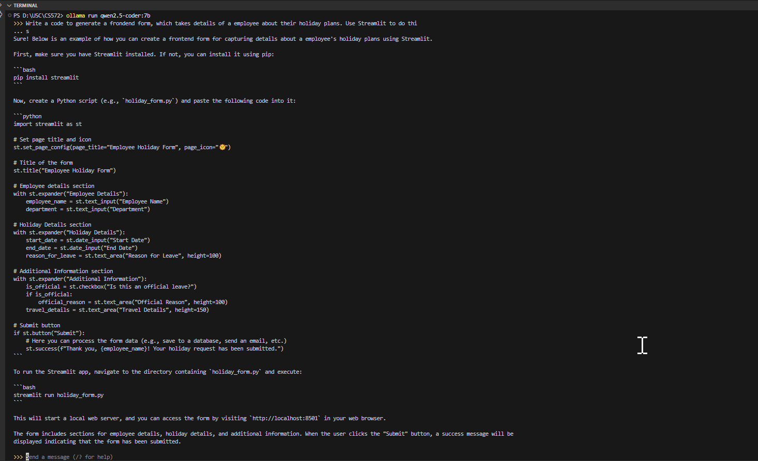

#### Prompt for class code: Write a model class to store the details taken above to store the employee holiday plans. Write that code in Java:

